AEM TASK 6

1Create Custom Workflow (my custom workflow)

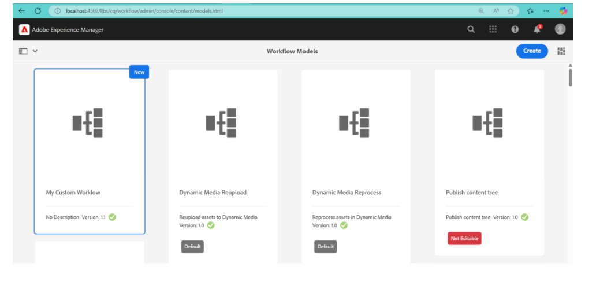

1. Create custom workflow process and print the page title in logs and run this workflow in page so that it can give some metadata in logs

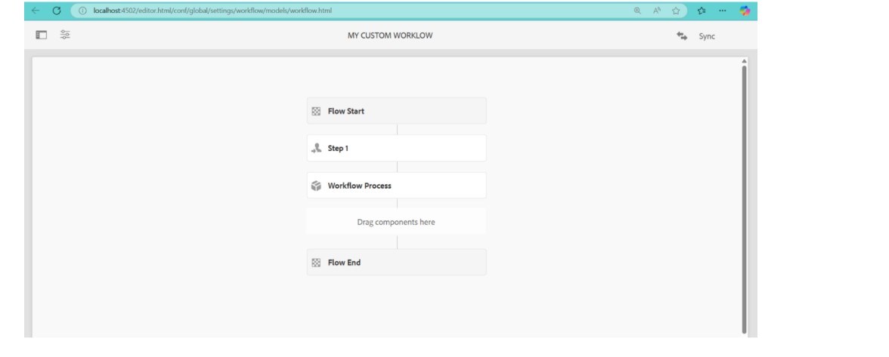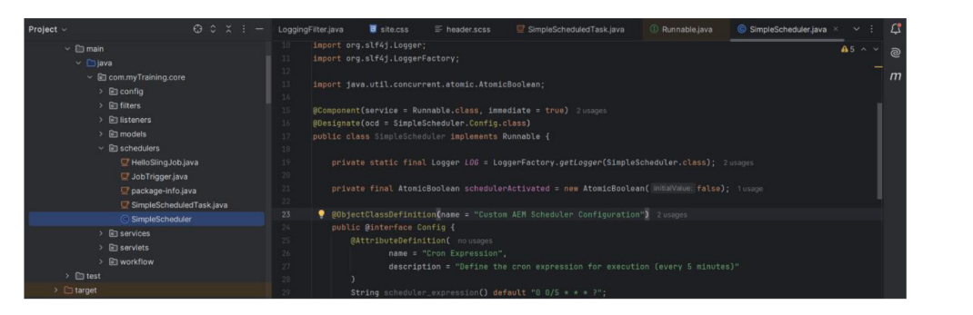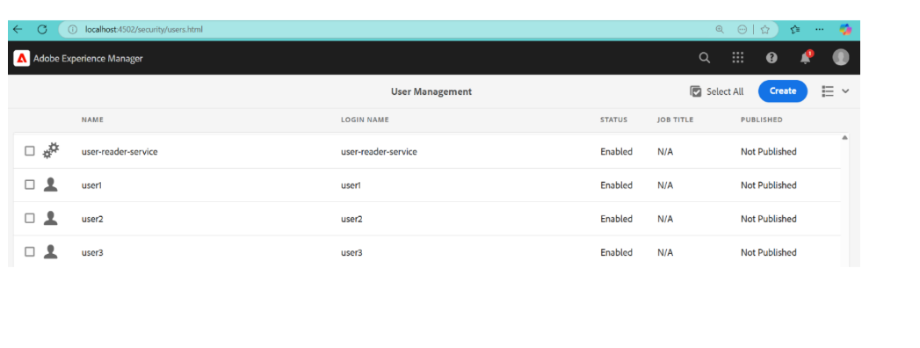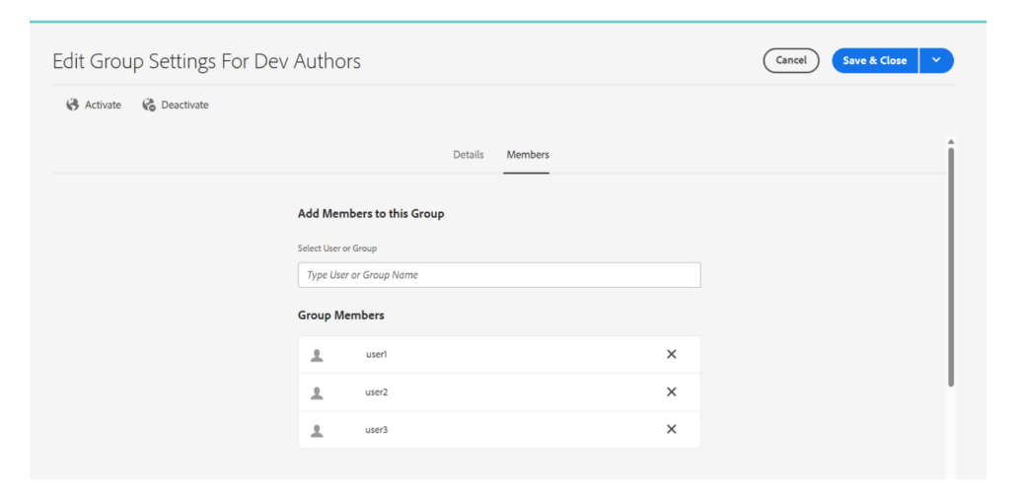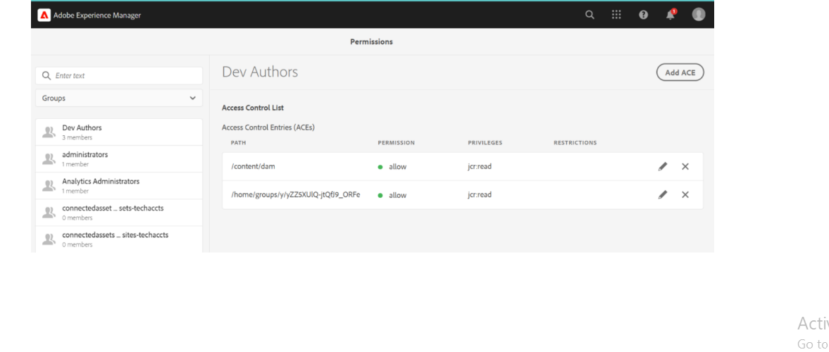

**Java Class: MyCustomWorkflowProcess.java**

**Location:**

core/src/main/java/com/assignment/workflows/MyCustomWorkflowProcess.java package com.assignment.workflows;

import com.adobe.granite.workflow.WorkflowException; import com.adobe.granite.workflow.exec.WorkItem; import com.adobe.granite.workflow.exec.WorkflowSession; import com.adobe.granite.workflow.model.WorkflowNode; import org.apache.sling.api.resource.ResourceResolver;

import org.apache.sling.api.resource.ResourceResolverFactory; import org.osgi.service.component.annotations.Component; import org.osgi.service.component.annotations.Reference; import org.slf4j.Logger;

import org.slf4j.LoggerFactory;

import com.adobe.granite.workflow.exec.WorkflowProcess;

import java.util.Collections;

@Component(service = WorkflowProcess.class, property = {"process.label=My Custom Workflow Process"})

public class MyCustomWorkflowProcess implements WorkflowProcess {

private static final Logger LOG = LoggerFactory.getLogger(MyCustomWorkflowProcess.class);

@Reference

private ResourceResolverFactory resourceResolverFactory;

@Override

public void execute(WorkItem workItem, WorkflowSession workflowSession, WorkflowNode workflowNode) throws WorkflowException {

String pagePath = workItem.getWorkflowData().getPayload().toString();

try (ResourceResolver resourceResolver = resourceResolverFactory.getServiceResourceResolver(Collections.singletonMap(ResourceRes olverFactory.SUBSERVICE, "workflowUser"))) {

String pageTitle = resourceResolver.getResource(pagePath).getValueMap().get("jcr:title", String.class);

LOG.info("Workflow executed for page: {}, Title: {}", pagePath, pageTitle);

} catch (Exception e) {

LOG.error("Error processing workflow: ", e);

}

}

}

1. Create Event handler in aem and print the resource path in logs.

The event handler will log the **resource path** whenever a new node is created.

**Java Class: ResourceEventHandler.java Location:**

core/src/main/java/com/assignment/listeners/ResourceEventHandler.java

package com.assignment.listeners;

import org.apache.sling.api.SlingConstants;

import org.osgi.service.component.annotations.Component; import org.osgi.service.event.Event;

import org.osgi.service.event.EventConstants; import org.osgi.service.event.EventHandler; import org.slf4j.Logger;

import org.slf4j.LoggerFactory;

@Component(

service = EventHandler.class, immediate = true,

property = {

EventConstants.EVENT_TOPIC + "=" + SlingConstants.TOPIC_RESOURCE_ADDED

}

)

public class ResourceEventHandler implements EventHandler {

private static final Logger LOG = LoggerFactory.getLogger(ResourceEventHandler.class);

@Override

public void handleEvent(Event event) {

String resourcePath = (String) event.getProperty(SlingConstants.PROPERTY_PATH); LOG.info("Resource added at path: {}", resourcePath);

}

}

1. create sling job to print hello world message in logs

This job will run asynchronously and print "Hello World" in logs.

**Java Class: HelloWorldSlingJob.java**

**Location:** core/src/main/java/com/assignment/jobs/HelloWorldSlingJob.java

package com.assignment.jobs;

import org.apache.sling.event.jobs.consumer.JobConsumer; import org.osgi.service.component.annotations.Component; import org.slf4j.Logger;

import org.slf4j.LoggerFactory; import java.util.Map;

@Component(

service = JobConsumer.class, property = {

JobConsumer.PROPERTY_TOPICS + "=assignment/helloworldjob"

}

)

public class HelloWorldSlingJob implements JobConsumer {

private static final Logger LOG = LoggerFactory.getLogger(HelloWorldSlingJob.class); @Override

public JobResult process(Job job) { LOG.info("Hello World from Sling Job!"); return JobResult.OK;

}

}

1. Create one schedular to print the yellow world in logs in every 5 mins through custom configuration using cron expression.

The scheduler prints "Yellow World" every 5 minutes using a **cron expression**. **Java Class: YellowWorldScheduler.java**

**Location:**

core/src/main/java/com/assignment/schedulers/YellowWorldScheduler.java

package com.assignment.schedulers;

import org.apache.sling.commons.scheduler.Scheduler; import org.osgi.service.component.annotations.Activate; import org.osgi.service.component.annotations.Component; import org.osgi.service.component.annotations.Reference; import org.osgi.service.metatype.annotations.Designate; import org.slf4j.Logger;

import org.slf4j.LoggerFactory;

@Component(service = Runnable.class, immediate = true, property = { "scheduler.expression=0 */5 * * * ?", "scheduler.concurrent=false"

})

@Designate(ocd = YellowWorldScheduler.Config.class) public class YellowWorldScheduler implements Runnable {

private static final Logger LOG = LoggerFactory.getLogger(YellowWorldScheduler.class); @Reference

private Scheduler scheduler;

@Activate

protected void activate() {

LOG.info("Yellow World Scheduler Activated");

}

@Override

public void run() {

LOG.info("Yellow World from Scheduler!");

}

}

1. 6. Create 3 users and add them in a group(Dev author create this new group) and give permission to read only for /content and /dam folder only and they should have replication access as well.

**Go to** <http://localhost:4502/useradmin>

1. **Click "Create User"**
   * User 1: user1
   * User 2: user2
   * User 3: user3
2. **Click "Create Group" → Name: "Dev Author"**
3. **Add user1, user2, and user3 to "Dev Author" group**

**Assign Permissions**

1. **Select "Dev Author" Group**
2. **Go to "Permissions" Tab**
3. **Set Read-Only Access to /content and /dam**
   * **Path:** /content → **Permission:** Read
   * **Path:** /dam → **Permission:** Read
4. **Enable Replication Access**
   * **Path:** /etc/replication → **Allow Replication**